Web 3.0 is being rising exponentially

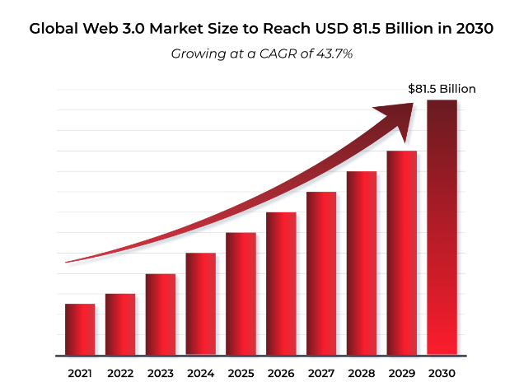

`Opportunity for block chain developers

